A: Photosynthetic reaction, rate of photosynthesis and use of glucose from photosynthesis.
- Phytoplankton are microscopic aquatic plants. They utilise the energy transferred from the sun for photosynthesis.

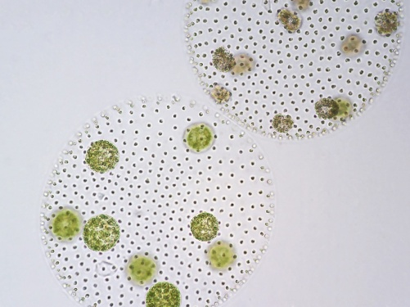
Scientists working in the North Sea collected 500 samples of sea water at the same depth and location every month for a whole year. They measured the number of phytoplankton and water temperature for each sample and calculated the mean. The graph shows the mean number of phytoplankton and water temperature each month.
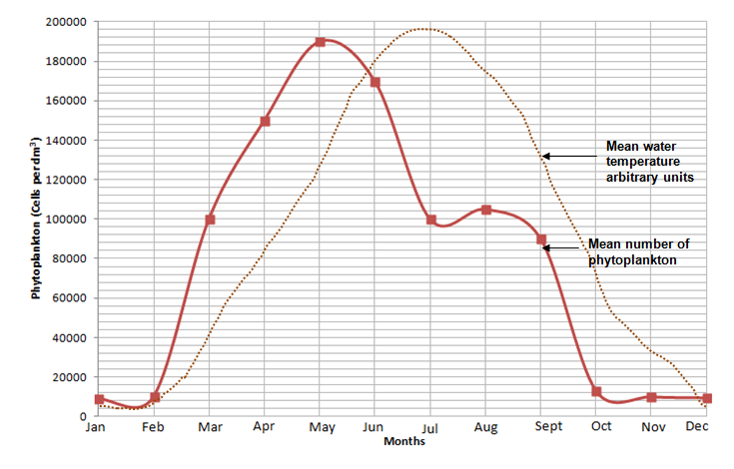
100 000
190 000
- Explain why the numbers of phytoplankton are lower in winter months. (2)
Lower temperature of water so metabolism is slow, so growth and reproduction will be slow.
Lower rate of photosynthesis as light intensity is lower. The phytoplankton cannot synthesise as much glucose and so many will die.
- Calculate the percentage decrease in numbers of phytoplankton between May and July. Write your answer to 3 significant figures. (3)
3 marks for correct answer to 3 significant figures
2 marks for correct answer but not to 3 sf
1 mark for incorrect answer but mentions 90 000

190 000 -100 000 = 90 000
90 000 / 190 000 = 0.47
0.47 x100 = 47.4% decrease
- Suggest the cause and reason why the numbers of phytoplankton fall at the start of summer. (2)
1 for a cause and 1 for related reason:
Water temperature is high enough
to denature metabolic enzymes causing death of phytoplankton.
More phytoplankton being eaten by animals
as they breed and increase in number.
- Van Helmont was a scientist born in the Netherlands in 1580. It was generally believed at that time that plants gained mass by eating soil.
Van Helmont designed an experiment to test this idea. The results of his experiment are seen below.
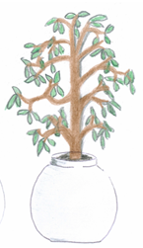
Only water was added for five years.
Willow plant in same iron pot.
Willow plant has a mass of 77.3kg
Mass of dry soil is 90.043kg
Willow plant in an iron pot.
Willow plant has a mass of 2.5kg
Mass of dry soil is 91kg

- Write a conclusion for this experiment using only the information provided. Explain your reasoning. (4)
Conclusion: Increase in mass of willow plant is linked to the addition of water. (1)
Three explanations why: (3)
The mass of the plant increases over five years by 74.8 Kg.
The soil mass has not changed significantly over 5 years.
The only extra factor added to the plant was water, therefore this must have contributed to the increase in plant mass.
The pot is the same and so did not influence results.

- List two extra investigations that would be needed to prove that the plant gained mass due to photosynthesis occurring? (2)
Two from:
Remove light but keep all other factors constant.
Remove carbon dioxide and keep all other factors constant.
Remove leaves/chlorophyll and keep all other factors constant.
- There is a total of 7000 x 10⁹ tonnes of carbon dioxide in the atmosphere. Photosynthesis converts 100 x 10⁹ tonnes per year into carbon compounds such as carbohydrates, protein or lipids. We call this carbon fixing.
- Calculate as a percentage, how much carbon is fixed per year from the atmosphere. Express your answer to 2 significant figures. (2)
100/7000 = 0.014
0.014 x100 = 1.4
1.4%
2 marks for correct answer of 1.4%
1 mark for 1.43% or 1.428%
- Suggest two reasons why the amount of carbon dioxide in the atmosphere stays relatively constant. (2)
Two from:
Combustion
Respiration
Decay

- A student carried out the practical which involved testing the effect of light intensity on the rate of photosynthesis. The pondweed was left to settle for 15 minutes in between each set of results being collected. The equipment was set up as shown below:
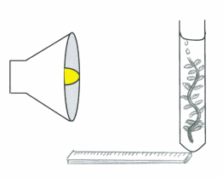
pondweed
0.2% sodium hydrogen
carbonate solution

bubbles of gas
bench Lamp
metre ruler
The student recorded the results in the table below:
Distance of lamp from boiling tube (cm) | Number of bubbles counted in 1 minute
 | Trial 1 | Trial 2 | Trial 3 | Mean number of whole bubbles | Light intensity (in standard form)  1/d²
20 | 10 | 15 | 18 | 10 + 15 + 18 = 43  43/3 =14.33  14 bubbles | 20 x 20 = 400  1/400= 0.0025  In standard form = 2.5 x 10⁻³
40 | 10 | 12 | 16 | 13 | 6.3 x 10⁻⁴
60 | 9 | 10 | 14 | 11 | 2.8 x 10⁻⁴
80 | 6 | 7 | 10 | 8 | 1.6 x 10⁻⁴
100 | 3 | 4 | 6 | 4 | 1.0 x 10⁻⁴

- Determine the mean number of bubbles of gas collected for each distance and record in the table. (2)
See table: 2 marks all correct
1 mark for 4 correct and 1 error
0 marks for more than 1 error

- (Higher Tier) Calculate the light intensity for each experiment and record in the table. (5)
See table: 1 mark for each correct calculation expressed in standard form
Maximum 2 marks if not in standard form.
Standard form is expressed in numbers between 1 and 10

- Plot a graph to show the effect of light intensity on the rate of photosynthesis. (4)

Line graph (1)
Plots pointed accurately (1)
Line of best fit drawn (curve) (1)
Axes labelled correctly (1)
Note: Must have drawn Light intensity rather than Distance.

- Use your graph to estimate the number of whole bubbles which would be released from the pondweed when the lamp was at a distance of 30cm. (3)

Look at graph and read off the number of bubbles at 1/d² figure of 1.1 x10⁻³ or 0.0011 (1 mark for using correct light intensity)
Approximately 13 or 14 (Use student graph for the answer here) (1 mark for reading own graph correctly)

Rounded up as can’t have half a bubble and it is an estimation. (1 mark for whole number answer)

- All the data shows an increase in number of bubbles collected during trial 3. Suggest two reasons why this may have occurred. Explain how this could be verified and how would you improve the method for the future. (6)

Level 3 (5-6 marks)
Potential issues with the experimental design are coherently described and explained. A logical method of verification is given for both issues and appropriate redesigns of the method suggested as a result.
Level 2 (3-4 marks)
Descriptions of potential issues are given with some explanation. Some verification procedures identified but these may not always be consistent with the issue. Improvements suggested.
Level 1 (1-2 marks)
Simple statements are made which demonstrate some understanding of the issues. The response lacks a logical structure.

Biological content

Water was warming up from the lamp by the time trial 3 occurred
and this increased the rate of photosynthesis.
Verify this by repeating the experiment and take temperature readings every 30 seconds.
If temperature was changing then use a heat shield or an LED lamp to reduce this
and check that the water temperature was the same at the start and end of each trial.

The pondweed had not yet reached the maximum rate of photosynthesis when recording began in trial 1
but it had settled by the time trial 3 occurred.
Verify by repeating experiment and doing all distances once and then repeating to see if similar results occur.
Leave the pondweed to settle for 30 minutes before taking each reading.
Check that the trial results are all similar and if not leave the experiment longer to settle.

- Photosynthesis is an endothermic reaction. Explain what this statement means. (2)

Photosynthesis is an endothermic reaction because it needs an input of energy.
The energy input comes from the sun.

Extended response question
- A farmer in the UK decided to grow lemon trees in two greenhouses in order to sell the fruit locally.
He had grown some lemon trees outside but these had not produced sufficient lemons to make it worthwhile. He decided to heat one of the greenhouses to 35°C and the other to 45°C.
There were the same numbers of lemon trees in each greenhouse and all other factors were kept constant. Both greenhouses contained healthy plants.
The lemons were all sold at 55p each.

 | Greenhouse A (35°C) | Greenhouse B (45°C)
Number of lemons produced in one year | 1050 | 879
Cost to heat the greenhouse per year | £438.00 | £492.80
Profit made | 1050 x 0.55p = 577.50 (1)  577.50 – 438 = £139.50 (1) | 879 x 0.55p = £483.45 (1)  483.45 – 492.80 = - £9.35 (1)

- Using the data given calculate the profit that the farmer made from each greenhouse and complete the table. (4)
See table

- The farmer was surprised by the results.

Use your knowledge of limiting factors to explain the results and suggest three changes the farmer should make to increase productivity and profit for the following year in Greenhouse A. (6)
Level 3 (5-6 Marks)
A detailed and coherent explanation is provided that considers a range of relevant points with linked reasoning and provide appropriate suggestions for Greenhouse A which will increase both profit and productivity.
Level 2 (3-4 marks)
An attempt to describe relevant points with some linked reasoning. Appropriate suggestions are provided for Greenhouse A which may be linked to profit and productivity.
Level 1 (1-2 marks)
Discrete relevant points made which are often not linked to reasons. Suggestions made for improving Greenhouse A with no appropriate link as to why or to profit and productivity.

Biology content
- At 35°C, the enzymes catalysing the photosynthetic reaction in the leaves are working under optimum conditions
- and so photosynthesis occurs at a maximum rate
- producing more glucose some of which is converted into carbohydrates stored in the lemons.

- At 45°C, the enzyme active sites are saturated
- and so no increase in photosynthesis occurs leading to no extra lemons being produced.
- The temperature is high enough for enzymes to start to become denatured and so ineffective.
- The extra heat being added to the greenhouse is wasted.

- Changes the farmer could make are:
- Use energy efficient glass to reduce heat loss to the environment saving money.
- Increase the amount of carbon dioxide so this is not acting as a limiting factor to the rate of photosynthesis and so increasing productivity and profit.
- Add lighting overnight to increase the hours that photosynthesis can occur and reducing light being a limiting factor during cloudy days and at night. This increases productivity and therefore profit.

- The following graph shows the effect of light intensity on the rate of photosynthesis for two plant species.

- Explain which plant is most likely to thrive in sunny positions in a garden. (3)
Species B (1)
Two from:
- Because as light intensity increases the rate of photosynthesis of species B continues to increase suggesting it normally experiences these types of intensities.
- Rate of photosynthesis in B is not limited until a much higher light intensity.
- A has a higher rate of photosynthesis at lower light intensities but the rate is limited by another factor earlier than B.

- Explain why species A might be unable to further increase the rate of photosynthesis even though it is in the same environmental conditions as species B and both receive the same amount of water. (2)
Two of:
Because it does not have enough chlorophyll/leaves and this acts as a limiting factor.
The chlorophyll in A is not adapted to working in high light intensities.
It does not have enough enzymes to catalyse the photosynthetic reaction to go faster.
Cannot mention carbon dioxide or water or light as question states these are not issues.
- (Higher tier) The graph shows the effect of temperature and carbon dioxide concentration on the rate of photosynthesis.

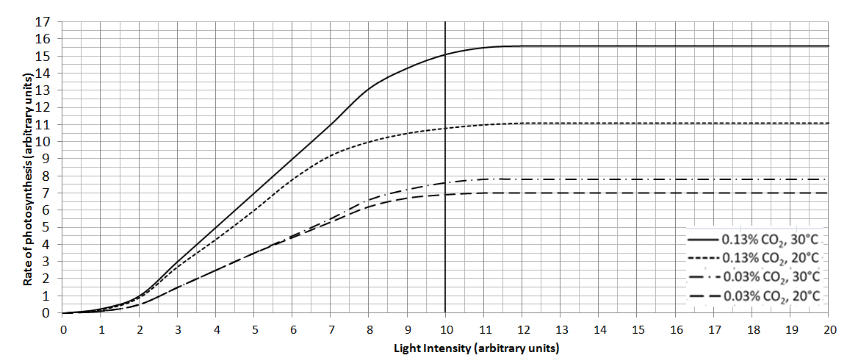

If light intensity is kept constant at 10 units, calculate the percentage increase in photosynthetic rate when:

- temperature is increased from 20°C to 30°C and carbon dioxide is kept constant at 0.03%. (2)
  - – 6.9 = increase of 0.7 units (allow tolerance of +/- 1 unit for each measurement) (1)
0.7/6.9 x100 = 10.1% (1)

2 marks for correct answer with no working
Check the % using the student’s figures – do not penalise twice.

- carbon dioxide is increased from 0.03% to 0.13% and temperature is kept constant at 20°C. (2)
10.8 – 6.9 = increase of 3.9 units (tolerance of +/- 1 unit per measurement) (1)
3.9/6.9 x 100 56.5% increase (1)

2 marks for correct answer with no working
Check the % using the student’s figures – do not penalise twice.
B. Transport in plants and structure of the leaf
1. Diffusion and active transport are vital processes in providing a plant with all the substances it needs to grow. Explain how these two processes deliver the named substances and describe where this occurs. (6)
Diffusion- 3 marks to include place, named substance and how it occurs
- passive process
- requires a concentration gradient/ gases diffuse from an area of high concentration to low concentration
- gas exchange occurs in the leaf
- carbon dioxide diffuses from air into leaf
- through air spaces in leaf
- oxygen diffuses into leaf for aerobic respiration
Active transport- 3 marks to include place, named substance and how it occurs
- needs energy
- to pump mineral ions (nitrates for example) from soil into root cells
- against concentration gradient
2. Explain how the structure of a leaf is adapted for photosynthesis (4)
4 of:
- Large surface area – to maximise light harvesting
- Thin – to reduce distance for carbon dioxide to diffuse through the leaf and to ensure light penetrates into the palisade and spongy mesophyll areas of the leaf
- Air Spaces – to reduce distance for carbon dioxide to diffuse and to increase the surface area of the gas exchange surface inside the leaf
- Stomata – pores to allow carbon dioxide to diffuse into the leaf and water to evaporate out (transpiration)
- Presence of xylem tissue (carries water and minerals to the leaf from the roots) and phloem (transports sugars and amino acids away from the leaf)
- Chloroplasts – mesophyll cells and guard cells contain many chloroplasts. These organelles contain the light harvesting pigment chlorophyll and are where all the reactions of photosynthesis occur

2. Extended response question:
Compare the processes of transpiration and translocation in a plant and explain the conditions that would bring about maximum transpiration. (6)
- Level 3 (5-6 marks)
Detailed comparison of transpiration AND translocation in terms of transport direction, vessels and substances AND an explanation of the environmental factors that increase the rate of transpiration.
- Level 2 (3-4 marks)
Basic comparison of transpiration AND translocation in terms of transport direction, vessels and substances or an explanation of the environmental factors that increase the rate of transpiration.
- Level 1 (1-2 marks)
Basic comparison of transpiration OR translocation in terms of transport direction, vessels and substances OR/AND an explanation of the environmental factors that increase the rate of transpiration.

Biology content:
In transpiration xylem tissue transports water from the roots to the leaves and stem whereas in translocation phloem tissue transports dissolved sugars from the leaves to the rest of the plant.

Increase temperature, air movement and light intensity all increase the rate of transpiration. Increased humidity decreases the rate of transpiration.

C. Plant hormones (Biology)
1. Extended response question:
Auxin is a plant hormone that controls growth.

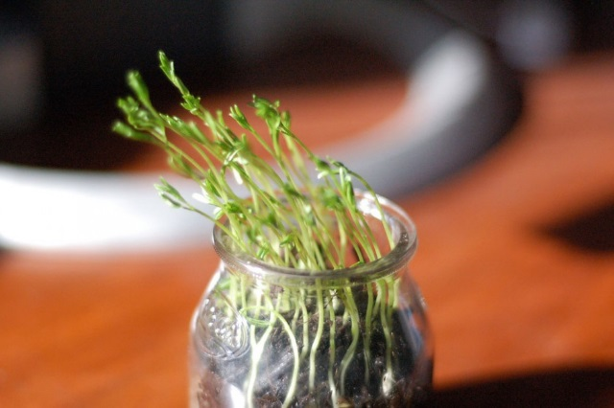

Describe and explain how auxin has made the plant grow towards the light. (6)

- Level 3 (5-6 marks)
The answer is well organised, clearly outlining the stages of phototropism including uneven distribution of hormone and cell elongation.
- Level 2 (3-4 marks)
The answer demonstrates an understanding of phototropism. Some keywords are used appropriately.
- Level 1 (1-2 marks)
The answer identifies some of the stages of phototropism but is unclear on how auxin influences growth.

- Auxin is present in the plant.
- light stimulates auxin to move to the shaded side of the plant
- auxin promotes cell elongation
- longer cells (on the shaded side) causes the plant to tile towards the light source

2. A team of scientists studied the effect of two weedkillers. Weedgone contained a plant growth hormone, Weedaway did not.
They tested the two weedkillers on potato crops and measured how many kilograms of potatoes were produced.
a. Name one control variable and describe how they should keep it constant. (2)
Variable and method must be linked to gain both marks
- size of field - measure
- amount of water – measure rainfall/control volume
- amount of light – light meter/control lighting/provide artificial
- temperature – thermometer/heaters
- other chemicals used – use/not, measure use/volume/etc.

b. Here are the results of their investigation:
Year | 2008 | 2009 | 2010 | 2011 | 2012
Kg of potatoes from field treated with Weedgone (plant hormone) | 51 | 42 | 50 | 52 | 51
Kg of potatoes from field treated with Weedaway | 38 | 37 | 36 | 38 | 37

i. Calculate the mean for Weedgone. (2)
• 51 (2 marks)
• evidence of 204/4 (1 mark)
ii. Use the data to describe the effect of the plant hormone on the mass of potatoes produced. (2)

- more potatoes produced/greater mass
- use of data to support

